MEANINGS OF ITEMS COMMONLY USED AT CUB SCOUT CEREMONIES
- Cub Scout colors Blue (truth and spirituality, steadfast loyalty, and the sky above) and Gold (warm sunlight, good cheer, and happiness)

- The seven rays of light on the arrow of light represent, in order, wisdom, courage, self-control justice faith hope and love.
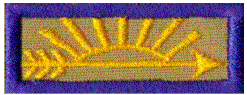

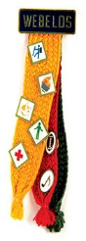
- Webelos colors - The three badge colors represent the three programs in the BSA: Cub Scouting (the yellow/gold), Boy/Varsity Scouting (the red) and "Senior Scouting" (used to be Exploring and now Venturing, the green). These are the same three colors found in the "WEBELOS Tartan", an official tartan (plaid) color combination recognized in Scotland (and is also referred to as the "Boy Scouts of America Tartan").

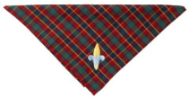

- Webelos neckerchief with 4 colors in it: the Blue & Gold of Cub Scouts and the Red and Green of Boy Scouts. The Green stands for the outdoors and nature, which Scouts are obliged to protect and care for. Red stands for bravery, being prepared to help others, and pride for our country.

- The symbol of Scouting is the Fleur-de-lys, which was used as the north arrow on old sailors' compasses. It will point the youth on the right way in life, just like a compass. The 3 points stand for the 3 points of the Scout Oath. The 2 stars are for truth and knowledge. The eagle is the symbol of the USA. The shield stands for freedom and the readiness to defend that freedom.

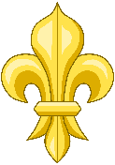
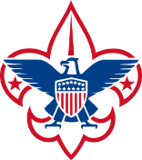

Classic Boy Scout
Fleur-de-lis Fleur-de-lis

- Candle light - stands for the help and encouragement given to Cubs by his leaders, family and friends.

- Red, White and Blue in U.S.A flag stand for, in order – Red - lifeblood of brave men ready to die or worthily live for this; our country. White - purity, cleanliness of purpose; thought and deed. Blue - faith and loyalty, like the eternal blue of the star-filled heavens.
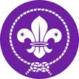
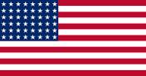

- World Scout Emblem - is the recognition that Scouting is a worldwide program. The left of the Fleur-de-lys signifies service to others, the middle signifies duty to God, the right signifies obedience to the Scout Law. The bond encircling the fleur-de-lys signifies the family of Scouting. The rope signifies the unity of the World Scout Movement. The knot signifies a knot that cannot be undone, symbolic of the strength of scouting's unity. The 2 five point stars are for Truth and Knowledge, two points of the original Scout Law. The colors signify purity, leadership and service.

