Quell Cub Scout chaos with these good-behavior techniques
By Mark Ray
Illustrations by Dave Wheeler
From the September-October 2012 issue of Scouting magazine
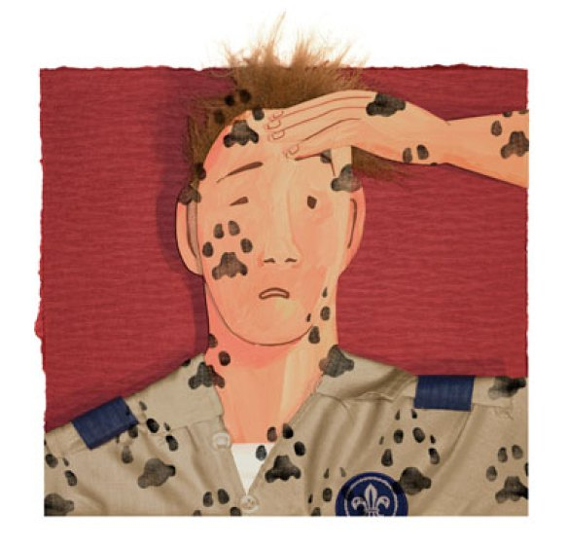
WHEN CHRIS MINNIEAR, Cubmaster of Pack 998 in Mason, Ohio, was filling in as his son’s Tiger Cub den leader, he tried a simple craft: making Kōnane (Hawaiian checkers) games. The cloth boards the boys made used flattened glass gems as game pieces. Things went well until near the end of the den meeting, when a pair of twins started throwing the glass gems. “Getting that under control was fun,” he says.
Fortunately, the incident happened at the end of the meeting. When he got home, Minniear realized the twins had managed to break every single game piece. Incidents like this taught Minniear how easily the controlled chaos of a den meeting can slip into uncontrolled anarchy.
How can you stop that from happening in your den? Here are some tips from Minniear and Caren Tamkin, a veteran San Diego Scouter who co-facilitated this summer’s Strictly for Cub Scouters conference at the Philmont Training Center.
Know Your Boys
Step one, Tamkin says, is to know your Scouts. Learn what they like and what makes them lose control. When in doubt, ask a parent. Tamkin says she once had a boy in her den whom she suspected of having attention deficit hyperactivity disorder, although he hadn’t been diagnosed. To get some insight into one boy’s energetic personality, Tamkin asked the boy’s mother to attend a few den meetings.
“She observed what he was doing,” Tamkin says. “She didn’t discipline him or anything, but she did give me some tips to help me.” For example, the boy was able to concentrate much better when he was chewing gum or playing with a pencil, things Tamkin wouldn’t have guessed without talking with the mother.
Establish Some Rules
Early in the Scouting year, establish some simple den rules (e.g., no hitting, no leaving the meeting room, no videogames). Put them on a poster that you display at every den meeting and refer to them often.
Many den leaders involve their Scouts in creating their own code of conduct, which works especially well with older boys. “I found that the Wolves were so black and white in the way they viewed the world that they weren’t really capable of coming up with a code of conduct that was loose enough for our purposes,” Tamkin says. “When they got to Webelos, then they were really good at coming up with a den code of conduct.”
Be Flexible
Of course, rules are not enough to keep boys in line. You need a program that holds their interest and can require a good deal of flexibility.
“I am very big on improv,” Minniear says. To that end, he always has a backup plan he can quickly put into place.
At the same time, he will let activities run long if the boys remain interested. “I’m not going to stop what’s going on if they’re getting some value out of it,” he says.
It also helps to remember that the real value of an activity may not be apparent on the surface. Once, Tamkin struggled to get her boys to make corsages for the pack’s blue and gold banquet. Instead of the boys making them in one meeting, she had to space out the work over several meetings. “It took us longer, and they weren’t as perfect as I would have liked, but that wasn’t the point,” she says. “The point was for all the kids to work together.”
Reward Good Behavior
Tamkin recommends that dens use a marble jar to reward the group’s good behavior. The concept is simple: Get a quart-size jar and a bag of marbles. At the end of each den meeting, have the boys rate how well they followed the den code of conduct. Put one or two marbles in the jar for each rule they obeyed. When the jar is full, treat the boys to ice-cream sundaes or playground time.
Tamkin says the key is to have the den rate its behavior as a group, not to point a finger at one misbehaving boy. Also, she says, “I don’t like the idea of taking something out of the jar [for bad behavior]. I don’t want to get to the negative side.”
Some den leaders prefer to use a “conduct candle” instead, blowing out the candle each time boys misbehave and offering a reward when the candle burns completely down. Tamkin prefers the marble jar because many meeting places ban open flames. Also, she says, “When I did try the conduct candle, they wanted to see how long their hand could stay over the flame.”
Marble jars are safer, but be sure to keep the lid on your jar. After all, those marbles can be just as tempting as Kōnane game pieces.
http://scoutingmagazine.org/2012/08/quell-cub-scout-chaos-with-these-good-behavior-techniques/

One of the developmental tasks of childhood is to learn appropriate behavior. Children are not born with an innate sense of propriety, and they need guidance and direction.

UNIT RESPONSIBILITIES
Misbehavior by a single member in a Scouting unit may become an unreasonable burden on that unit and constitute a threat to the safety of those who misbehave as well as to other unit members. Adult leaders of Scouting units are responsible for monitoring the behavior of the youth members and interceding when necessary. Parents of youth members who misbehave should be informed of the problem and asked for assistance in dealing with it.
The pack committee should review repetitive or serious incidents of misbehavior in consultation with the parents of the child to determine a course of corrective action, including possible revocation of the youth’s membership in the pack.
DENDISCIPLINE
Young boys tend to be noisy, active, and full of energy. But you can keep your Cub Scouts under control and handle the noise they create.
The first step is to accept the fact that they will be noisy and active and to find a meeting location where that’s not an issue. Beyond that, effective discipline is 90 percent preparation.
Part of that preparation is the awareness of what boys are like at various ages. Make assets out of their abilities and interests. Then as they mature, so do you—right along with them.
The other element of preparation is planning appropriate activities and having enough physical and human resources on hand to keep the group going for the entire meeting. Some people think that the best kind of control is inner control, but Cub Scouts are a long way from reaching such a goal. This does not mean that they are too young to try. You can put first- and second-graders’ interest in fairness to work to create some operating rules that the group members agree to follow.
You can encourage positive behavior in many ways, including
► Expressing clear expectations of good behavior to the boy and his family
► Developing a den code of conduct with the boys
► Using two-deep leadership, especially on trips and outings
► Having trained den chiefs help with den activities
► Following the suggested Cub Scout den meeting structure outlined in BSA resources
► Using positive recognition or reinforcement aids such as good conduct candles, marble jars, and stickers
DEN CODE OF CONDUCT
The den leader and the boys in the den should develop a den code of conduct—or set of group rules. Introduce the subject of a den code of conduct during an open discussion of how friends act toward one another. Boys will often contribute proposals that relate to safety, to respect for property, and to relationships with others. You can make suggestions along these lines if the boys don’t bring them up.
A few rules are enough for a start, but the boys might need to add others from time to time. They also might want to write out their den rules and sign on a line at the end of the list. This is a way of sharing with parents and guardians the expectations of their sons.
Although groups of boys of this age will have their good days and bad days, they are most likely to try to live up to rules that they helped develop themselves. Boys need to learn to judge their behavior in terms of more than conformity to rules. They need to learn about caring, too. Just as they can make up rules, they can decide on some of the caring values that they want to represent their den.
GUIDANCE USING VALUES
The ideas of fairness, helpfulness, and cooperation are all found in the Scout Oath and Scout Law. These important values can be a good start for discussions about conduct. With guidance, even young Cub Scouts can discuss their actions and decide how they fit with the den’s chosen values. Such exchanges not only reinforce these values but also help boys develop critical thinking skills.
Webelos Scouts are much more adept at developing rules and can generally be depended on to adopt reasonable ones for their group. They might want to change rules from time to time as circumstances change. By age 10, boys are beginning to understand that even public laws are made by people and that people can change them. They are ready to discuss rules in a fairly businesslike manner and will engage in a lot of bargaining with peers and adults.
Webelos Scouts also need active encouragement if they are to continue developing a caring orientation in their lives. They are ready to begin exploring the meaning of responsibility for the welfare of others. You can use their growing ability to see the perspective of others as a tool in your guidance. For example, encourage them to talk about the “whys” of the Scouting for Food Good Turn in terms of real human needs in their communities.
Give boys responsibility to help them think more deeply about positive attitudes, beliefs, values, norms, and actions. Teach boys how to learn from experience and how to gain some mastery over the events in their lives. This approach will take effort at the beginning but will soon begin to take hold as the boys learn to discipline themselves.
HELPFUL HINTS FOR DEN DISCIPLINE
- Use the Cub Scout sign to get attention. When boys and adults see the sign, each should stop talking and raise his or her arm in the sign. Eventually, the room will be quiet. Don’t shout or yell for attention. Wait until everyone is quiet before speaking.
- Keep den and pack meetings fast-paced, and have many interesting activities. Have activities for early arrivals, and alternate boisterous and more quiet activities. Keep in mind that you don’t have to crowd everything into a single meeting. There’s always the next meeting.
- Try to get to know each boy. Find out what he likes and dislikes. Don’t be afraid to let the boy know something about yourself. Stay in contact with his family and be responsive to what might be going on in other aspects of his life.
- Behave toward boys impartially, regardless of race, social class, religion, and any other difference. Boys expect fair treatment, and the example of all leaders becomes their model. If you make promises as a leader, you must make every attempt to keep them; at the same time, point out that at times, promises must be broken for good reasons. Knowing that young boys don’t have a clear idea of “maybe,” you need to offer as much guidance as possible concerning indefinites.
- Listen attentively and try to understand what is written or spoken. If you have trouble understanding a boy, ask him to clarify. If possible, try to look at the situation from his point of view. Encourage him to tell how he feels, but resist the temptation to tell him how he should feel. Remember that boys are boys, and they do not yet have the maturity of an adult.
- Don’t criticize a boy in front of his den or pack; he will feel betrayed and humiliated. Wait until you can talk with him alone (yet in view of other adults, in accordance with Youth Protection policies). Get him to tell you what went wrong from his perspective, and then explain how you interpret the situation. Make an effort to find some common ground and begin once more.
- Focus on the positives and minimize the negatives. Help boys to look for good in every situation. Remember to give praise when it is earned and even when it’s not expected. Robert Baden-Powell, the founder of Scouting, said, “A pat on the back is a stronger stimulus than a prick with a pin. Expect a great deal from boys and you will generally get it.”
- Give boys opportunities to make choices. Provide real options and involve them in the planning of group activities. Sharing the power as well as the fun gives boys a feeling of ownership of the group’s success and responsibility for things that do not go well.
- Provide boys with appropriate challenges. What is exciting to a 7-year-old might bore a 10-year-old. What is exciting to a 10-year-old might frighten a younger child. Focus on the strengths of each developmental stage, and develop the program with the boys. Remember that the youngster who tests your patience the most might need Cub Scouting the most.
- Take some extra time to reflect on each meeting and learn from your own experience. Start with what went particularly well. What made it go? What part did you play? What parts did the boys and/or other adults play? How can this combination work again? Also focus on what didn’t work well. What aspects of the meeting needed more planning, resources, and leadership? What could have been done to prevent problems? Could these ideas be put into action earlier the next time a problem comes up?
Not all areas of behavior can be treated as subjects for discussion, particularly when dangerous, intentionally hurtful, or offensive behaviors are involved. On some occasions, leaders must insist on obedience and save the dialogue for later. Boys sense when some behaviors or events are getting out of control. In these instances, they expect adult leaders to protect them and to restore order.
The best time to confront a crisis is when it occurs. Don’t wait for it to resolve by itself. Afterward, the entire group might need time to calm down. If only one or two boys are involved, take them aside and talk to them tactfully. Recognize that some boys have difficulties that are too great to be solved in a Cub Scout den. Share your concerns with and seek assistance from the boy’s parent or guardian or your pack committee or unit commissioner.
SOLUTIONS TO PROBLEMS
Be positive. Figure out what is not working quite right. Is it the meeting? Is it the meeting place? Is it the activity? Is it the Cub Scouts, or a particular Cub Scout? Now is a good time to work with the boys on building group responsibilities and leadership skills.
Use group problem-solving skills, which could help the Cub Scout throughout his life. Some boys have difficulty learning positive group skills. Try to support them by guiding them through some simple group decisions. If a plan or activity is not working, guide the Cub Scouts to use their ingenuity to create a different plan. As the boys become more accustomed to making group plans, they will also become better able to handle conflict with others.
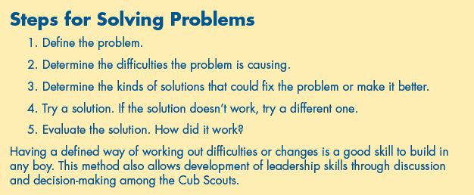

https://cubscouts.org/library/behavior-and-discipline/

Controlling Chaos at Cub Scout Meetings
by Kimberly Cook | Nov 21, 2014 | Volunteers
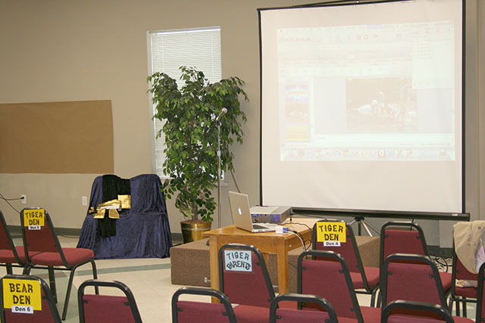

Let us face the hard truth: Cub Scouts have a natural affinity for chaos. Not only are they easily led into it, but they love it. In fact, the more out of control the situation is, the more Cubs like it. If you ask a Cub Scout whether he enjoyed a chaotic pack or den meeting, he will likely say “yes.” If you ask the attending parent the same question, you will likely get the opposite answer. Sadly, if parents think meetings are out of control, they will be likely to not attend or keep their Cub home the next time. So, if a Cub leader is not a schoolteacher, trained in the art of classroom management, how does he or she maintain an appropriate level of control to accomplish the goals of the meeting, while at the same time allowing the Cubs to have fun?
Here are some tips that will help:
Set expectations before the meeting.
There are several ways to come up with these rules for behavior. At a first den meeting, get the boys to make their own list of behavior rules. These might include rules such as “no talking when a leader is talking” or “no running around the room.” For pack meetings, the Cubmaster should communicate rules that suit the formality of the situation. At a minimum, this should include no talking while a Cub or leader is talking at the front of the room. Put these rules on a slide or poster that is shown at the beginning of every meeting. Realize that the type of activity may dictate what is expected. During a game, the level of noise will naturally be louder than during the presentation of a den skit. Most Cubs will naturally realize what is appropriate, but the leader should quickly step in when behavior is out of line with what is expected.
Once you make a rule, enforce it.
If you choose to ignore impolite or disruptive behavior once, you have nullified the rule you made. In a Cub’s mind, a rule that is not enforced is not a rule at all. If a Cub sees another Cub violating a behavior rule, he will be the next one to break it. Don’t beg or plead for appropriate behavior; require it. Use the Cub Scout sign to get attention on a regular basis. Don’t resume the activity until everyone is quiet, including parents.
If you are a Cubmaster with a high tolerance for Cubs chatting in the background, realize this behavior may not bother you, but it might greatly bother others in the room, including Cubs. Allowing Cubs to talk over others also teaches bad manners. Do your best to run an orderly meeting so that everyone can enjoy the activities you have planned. Enlist an assistant to help with keeping order if that is not your strength.
Communicate behavior expectations to parents and den leaders.
Parents value order and reinforcement of good manners. If you let parents and leaders know what you expect in terms of behavior, they will help you achieve it. If you are having trouble with a particular Cub’s behavior, explain the problem behavior to the parent and enlist his or her help to develop solutions.
Remind parents that siblings attending meetings must follow the same behavior rules as Scouts and should be attended at all times. Seat parents and leaders behind Cubs at pack meetings and let them know you expect them to intervene when Cubs fail to meet behavior expectations. A leader at the front of the room cannot be expected to monitor and control the behavior of a large number of Scouts.
Get focused attention of Cubs before starting a meeting.
Wait as long as necessary to ensure Cubs are quiet and listening before starting the meeting. Never start a meeting over the chatter of Cubs who are not paying attention. If you don’t start the meeting with their attention, you will likely fail to gain it during the rest of the meeting. Use a formal ceremony (such as a flag ceremony or recitation of the Pledge of Allegiance or Cub Scout Promise to start the meeting, because it will draw the focused attention of Scouts and set the appropriate tone for the rest of the meeting.
Plan some high-energy activities in the middle of your meeting that will allow for chaos and movement.
Boys thrive on activity and they crave some amount of chaos. For den meetings, include a high-energy game that gets boys outside, when weather and conditions permit, and involves physical activity. For pack meetings, include cheers or group games when Cubs can collectively be loud. Boys don’t like being quiet all the time, so allow for planned chaos. How much chaos is too much? If you can’t conduct the activity in a somewhat organized fashion, it is time to pull back on the reins. Help the boys realize they can’t have fun if they don’t cooperate and listen to instructions.
End your meeting with a focused, quiet activity.
Always close a meeting with a quiet activity, such as announcement time, Cubmaster’s or Den Leader’s Minute, or a ceremony to refocus attention. If you follow the suggested Cub Scout meeting template, it will have the right balance of activity and quiet. Make sure every meeting has a definite end.
Require Cubs to give full attention when another den or Cub is presenting.
At a pack meeting, the Cubmaster and other leaders should ensure a den or Cub making a presentation has the undivided attention of the Cubs watching. Don’t rely on the den making the presentation or that den’s leaders to help with this. Likewise, in a den meeting, the den leader should ensure Cubs are polite to each other, giving other Cubs their full attention during presentations.
Use positive reinforcement whenever possible.
Phrase rules in a positive way. Instead of saying, “No talking while the Cubmaster is talking,” say, “Listen when the Cubmaster is talking.” Focus on what Cubs should do instead of what they should not do. Rather than calling down the Cub who is making too much noise, offer a reward or praise to the Cub who is sitting and listening quietly. (Hopefully, you can find one).
If you are having control issues, use a Good Behavior Jar: Drop in a marble or piece of candy each time the group is polite or when you observe a Cub showing good manners. At the end of the meeting, if the jar is gets to the “great behavior” mark, offer a reward to the group (a small piece of candy, perhaps) to take home. You can take a piece of candy out of the jar if behavior does not meet expectations. A Cubmaster or den leader can designate a behavior monitor (volunteer den leader or parent) to come forward during the meeting to put a token in or take a token away, depending on the behavior of the Cubs. Make it fun by giving the monitor a decorated hat to wear. If you have a parent who is complaining about too much chaos during meetings, appoint him or her to be the monitor, making the parent a partner in the solution.
Following these guidelines will put you on your way to having happy parents, happy leaders, and productive, fun meetings.

Kimberly Cook is a Cubmaster and den leader veteran, having previously served as den leader, Asst. Cubmaster, and Cubmaster for packs in Vestavia Hills, Alabama, and Homewood, Alabama. She currently serves as Unit Commissioner for two packs in the Vulcan District of the Greater Alabama Council; Vulcan District Committee member; and Merit Badge Coordinator/Membership Chairman for Troop 76.

http://www.vulcandistrict.com/controlling-chaos-cub-scout-meetings/

